A Cyber-Physical System for Pervasive Air Pollution Monitoring

Ashlin Saju and Alex Aravind

*Department of Computer Science*

*University of Northern British Columbia, Canada*

E-mail: *(saju, csalex)@unbc.ca*

*Abstract*—Among the risk factors with serious health issues, air pollution ranks the highest annually. Air pollution is considered as the main cause for the majority of deaths and suffering with chronic diseases. To address this issue, we believe, active participation from public on collecting and interpreting data, educating to change the behavior of individuals and industries, and helping to control and manage pollution sources effectively is crucial. Fortunately, this goal appears to be achievable due to recent revolution of electronic and computing technologies. It is possible that small, portable, and off-the-shelf pollution sensors along with low power processors and wireless communication modules can be bought at low cost. Also, the availability of open source software for general and specific purposes is consistently increasing. What is needed is a system framework on how to build a low cost portable pollution monitoring system and install necessary open source software modules to make the system operational with least effort and technical knowledge. Contributing to achieve this task is the objective of this work. We propose a portable pollution monitoring system framework and demonstrate its feasibility with a prototype system that we built in our lab using low cost off the shelf pollution sensors and open source software.

*Index Terms*—Cyber Physical Systems, Sensor Networks, Pollution Monitoring.

# I. INTRODUCTION

With the advancement in wireless communication and sensing devices, a revolution is taking place to develop new kinds of systems referred to as *cyber-physical systems* (CPS) [2], [14]. CPS has enormous potential for practical applications such as surveillance, monitoring (of health, weather, etc.), and control and management of the activities such as production, traffic, etc. To achieve these goals, a related paradigm called *Internet of Things* (IoT) has emerged parallely to help accelerate the development of CPS. IoT is essentially a network of uniquely addressed elements such as processors, sensors, actuators, and communication devices that can interact among them seamlessly using standard communication protocols.

As the new solutions emerge due to technological advancements to handle known problems, new issues that have profound impact on our day-to-day life also start to emerge often with an alarming intensity. One such issue is the pollution in the air that we breath. Air pollution is a complex mixture of gases and particles whose sources and composition vary over space and time [10]. The burning of fossil fuels, exhaust from factories and industries, and mining operations are the major contributors to air pollution.

Air pollution has increased significantly after the industrialization and urbanization have taken place, and people are unaware of the fact that the impact it causes to our health. As urban areas have a high density of population, maintaining air quality is becoming more and more challenging [4]. The major impacts of air pollution are premature deaths, cardiovascular disease, stroke and other respiratory diseases. The state of global air 2017 has discussed the effects of long-term exposure to harmful air pollutants such as particulate matter which contributes to over 4 million premature deaths and is estimated to double by 2050 if the issue remains unattended [10]. Therefore, the urgency for a global attention to mitigate the issue require no further emphasis.

## A. Motivation

One of the important components in solving this issue is to increase the awareness among all stakeholders, particularly common people about the current situation and its impact so that they can act on it. The conventional method of monitoring the air quality with the help of a few heavyweight expensive stationary monitoring systems typically installed by the state may not be effective enough for this task. To achieve the goal effectively and without further delay, pollution monitoring must become part of daily activity for everyone. For that the devices to monitor pollution must be small, portable, inexpensive, and part of a global system. With the technological advancement of low cost computing, communication, and sensing devices, and the revolution and the importance of open source software [1], we believe it is possible to build pervasive air pollution monitoring system with commodity hardware and open source software. Now the question is how to design such pollution monitoring devices faster and make them accessible to as many as possible.

Achieving the above stated goal requires a suitable system framework that can help to accelerate the process of the design and implementation of a air pollution monitoring system using the of-the-shelf commodity hardware and open source software. There are some recent attempts in this direction, but none is comprehensive and simple enough to follow and build a air pollution monitoring system with a little or moderate effort. This paper is an attempt to fill that gap by first proposing a simple and comprehensive framework and then demonstrating its feasibility and use by creating our own pollution monitoring system that is operational in our lab.

With some additional work, we are planning to release the framework with suitable documentation to the public. If accepted for a presentation in the conference, we plan to demonstrate a fully developed and tested pollution monitoring system with a proper 3D printed cases at the the conference. Our contribution is a step towards inspiring and motivating not only the public to use the device, but also many amateur electronic hobbyists to buy the hardware locally and download the associated software to build their own pollution monitoring device to aid the mission of creating a pervasive pollution monitoring system.

## B. Problem, Research Questions, and Research Trend

The quality of the air we breathe not only impacts individual’s health but also has a significant cumulative effect on public health, global environment, and worldwide economy [18]. Air pollution can cause heart disease, chronic obstructive pulmonary disease (COPD), stroke, and lung cancer, etc. On a daily basis, people could suffer from difficulty in breathing, coughing, wheezing, and asthma [18].

Some important questions to be addressed related to the issue of air quality are: What kind pollutants affect the human health most? How to measure them? Who should participate in the measurement? As the pollution is in the atmosphere, should it not be measured everywhere all the time? If so, what kind of infrastructure is needed to facilitate such a ubiquitous measurement? Pollution is a complex mixer of gases and other pollutants. Simply measuring and displaying individual pollutants may not be useful. What kind of metrics are useful for both the public and decision making authorities? These metrics must educate the public, rather than confuse, to avoid breathing polluted air and also influence the authorities to act to mitigate. Basically, they should help authorities to make suitable policy decisions that could in turn influence the polluters to change their behavior.

Due to its importance and urgency, global problems such as air pollution, global warming, cancer, etc., have drawn a lot of interest and attention not only from scientists but also from public to conduct research to address the problem [8]. These kinds of global problems also lead the way for a new paradigm shift in the way research is conducted. Traditionally, research is done mostly by abstracting some specific aspect of an important issue to its simplistic case (a well defined problem) and then solving it using some sophisticated derivations, algorithms, and/or experiments by expert scientists either in isolation or with collaboration from a few scientists of similar caliber and students.

Recent times, this practice is slowly shifting to solve real world problems collectively by participation from various stakeholders with differing level of understanding and skills. The later approach, referred to as citizen science, primarily identifies established tools and techniques from the literature and applies under a suitable framework in a cooperative and iterative manner to solve big issues [8]. Although there are legitimate concerns raised about this paradigm shift, citizen science is expected to make unprecedented impact on contributions to science, research, policy, and society [12]. We believe this paper contributes towards encouraging and helping citizen science to solve the issue of air pollution.

## C. Contributions

This paper has the following four key contributions.

1. A simple and comprehensive *cyber-physical system framework*, that can be used to design a pervasive pollution monitoring system using off-the-self commodity hardware and open source software components, is proposed.
2. A functional pollution monitoring system that we designed and implemented based on the proposed framework is presented.
3. *Air Quality Index (AQI) and Air quality health index (AQHI)*[1] are reviewed and adopted in our system. 4) Results such as pollution level, AQI, and AQHI at UNBC are demonstrated.

# II. ARCHITECTURE OF THE PROPOSED FRAMEWORK

The proposed architecture contains five essential elements: Sensors, processing unit, mining repository, animation and analytics modules, and communication middleware as shown in Fig. 1.

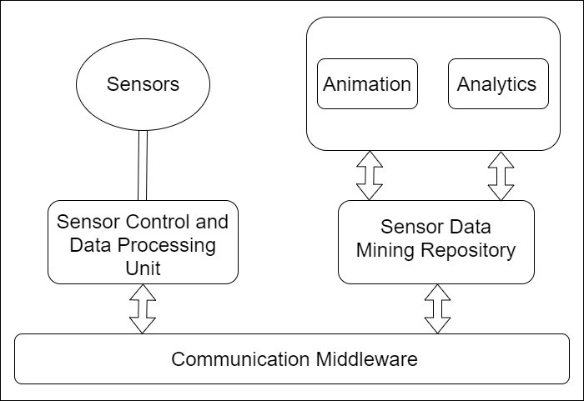

## Fig. 1: System Architecture

* Sensors and Communication: Sensors to collect data from the environment as per their schedule. Communication module essentially sends the sensor data to mining repository. It can occasionally receive data from other nodes and servers. These two modules are controlled by sensor control and processing unit.
* Sensor Control and Processing Unit: This module has two primary purposes: (i) control the sensors in collecting data; and (ii) filter and process the collected data and then forward, if necessary, to the mining repository through the communication module.
* Mining Repository: This module stores and maintains the sensor data that will be used by the search analytics service to generate graphs and other meaningful results. For IoT application such as this, a near real time search engine with standardized API to enable easy access to data must be integrated with the repository. As it has to store large volumes of data, it also requires capabilities such as sorting and filtering to segregate and organize data so that it can be accessed efficiently all the time.
* Animation and Analytics: These components are to provide statistical data analysis and visualization through intuitive graphics services to help users to make decisions. Particularly, analytics component is needed to perform statistical and machine learning functionality and animation component is to display the necessary data to users. Since the system is aimed to be used by various stakeholders including common people, we would like to emphasize the importance of accurate and intuitive graphic display if it is intended to used effectively.
* Messaging Middleware: This is a software layer that connects various heterogeneous components for seamless communication between them. Such a system allows the system designer and the programmers to focus on building standard, adaptable, and effective solutions rather than worrying about the finer details of the underlying communication issues [12].

We advocate such a modular system to be designed and implemented using off-the-shelf commodity hardware and open source software.

### A. Edge Computing for Sensor Data Processing

Two important aspects of any IoT system is preserving energy of portable devices and security of data. To save energy, the decision on when to collect data (data collection schedule) and when to forward a data to the mining repository (data transfer schedule) are very critical. Communication is a costly operation. We recommend the policy of transferring data to the servers only when absolutely necessary. Such computing paradigm, referred to as edge computing, is gaining popularity particularly for IoT systems [11].

Essentially, as advocated by edge computing, we recommend to use energy-aware data collection and data transfer scheduling algorithms at sensor nodes and employ suitable machine learning algorithms on the server side to maintain the quality of output display. For example, if the pollution level is stable or the internet connectivity is poor, then there is no need to communicate the sensor data to the server. In this situation, the machine learning algorithm can draw suitable values based on past history and depending on its confidence level the data can be projected either as actual or projected. With this higher level description of the proposed framework, we next describe a prototype system that we have designed and implemented.

# III. A PROTOTYPE IMPLEMENTATION

To demonstrate the feasibility of our proposed framework, we designed a portable pollution monitoring system that we designed using low cost commodity hardware and a open source IoT application software. Before presenting our prototype, we briefly discuss about the major pollutants and their measurement metrics.

## A. Air Pollutants and Measurement Metrics

Based on the severity of health impact, different countries measure different set of pollutants. For example, India measures 8 major pollutants such as particulate matters (*PM*), ozone (*O*3), nitrogen dioxide (*NO*2), carbon monoxide (*CO*), sulfur dioxide (*SO*2), ammonia (*NH*3), and benzene (*C*6*H*6) (in some places lead (*Pb*) instead). Most other countries measure a subset of these pollutants and, for example, Canada measures *PM,O*3*,NO*2*,SO*2 and *CO* [3].

Particulate matters are measured at two levels; 2.5 micron size particles (*PM*2*.*5) and 10 micron size (*PM*10), and they are measured in micro-grams per cubic meters (*µg/m*3). *CO* is measured in parts per million (*ppm*) and other gases are measured in parts per billion (*ppb*). These individual measurements make less sense to the common public and therefore are not very helpful in understanding the cumulative impact of the air quality. Therefore, two other combined metrics namely air quality index (AQI) and air quality health index (AQHI) are proposed and used by different countries [3]. India, USA, UK, and many other countries use AQI and Canada introduced and uses AQHI. These metrics are designed by carefully examining those pollutants which are harmful to human health. AQI is a piecewise linear function of the pollutant concentration and is measured using the following formula.

*AQI* = *Max*{*Ii*|*i* = 1*,...,*8} (1)

where *Ii* is an air quality subindex corresponding each pollutant and it is computed as

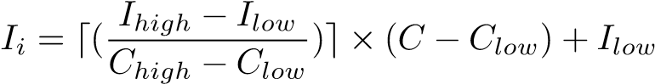 (2)

where *C* is concentration of the *ith* pollutant. *Clow* and *Chigh*, respectively, are lower and upper concentration breakpoints of *C*. *Ilow* and *Ihigh*, respectively, are index breakpoints correspond to *Clow* and *Chigh*. The value of AQI varies from 0 to 500, which groups them into six main categories: 0-50 (good); 51-100 (satisfactory); 101-200 (moderate); 201-300 (poor); 301-400 (very poor); and 401-500 (severe).

Health Canada and Environment Canada developed AQHI based five major pollutants *PM*2*.*5*,O*3*,NO*2*,SO*2*,* and *CO*. Later the last two pollutants were dropped from the calculation as they were identified to contribute very less in predicting health effects in Canada. AQHI computed using the following formula.



where *A* = 0*.*000537× concentration of *O*3, *B* = 0*.*000871× concentration of *NO*2 and *C* = 0*.*000487× concentration of *PM*2*.*5. The value of AQHI varies from 1 to 10+, which again groups into four categories: 1-3 (low risk); 4-6 (moderate risk); 7-10 (high risk); and above 10 (very high risk).

Now the question is which is a better measure, AQI or AQHI? Since AQI is based on a single pollutant, it is hard to see its direct relationship with human health compared to AQHI [3]. On the other hand AQHI is based on the relationship between the major air pollutant mix and mortality risk in 12 Canadian cities, it is not clear it can be directly generalized to rural areas or other cities across the world [3]. So there is a room for research on developing a better index suitable for individual places based on the pollution and mortality data collected in that particular location.

## B. Air Pollution Monitoring Prototype

In Section II, we proposed a higher level generic framework to guide building a air pollution monitoring system using low cost commodity hardware and open source software. As the choices for these hardware and software components are enormous and is keep changing as the technologies advance, suggesting one specific combination is hard and also not helpful if the hardware is not available globally at low cost. Therefore, we decided to experiment with a few options of using most commonly available hardware components. To start with, we designed a functional air pollution monitoring hardware system shown in Fig. 2.

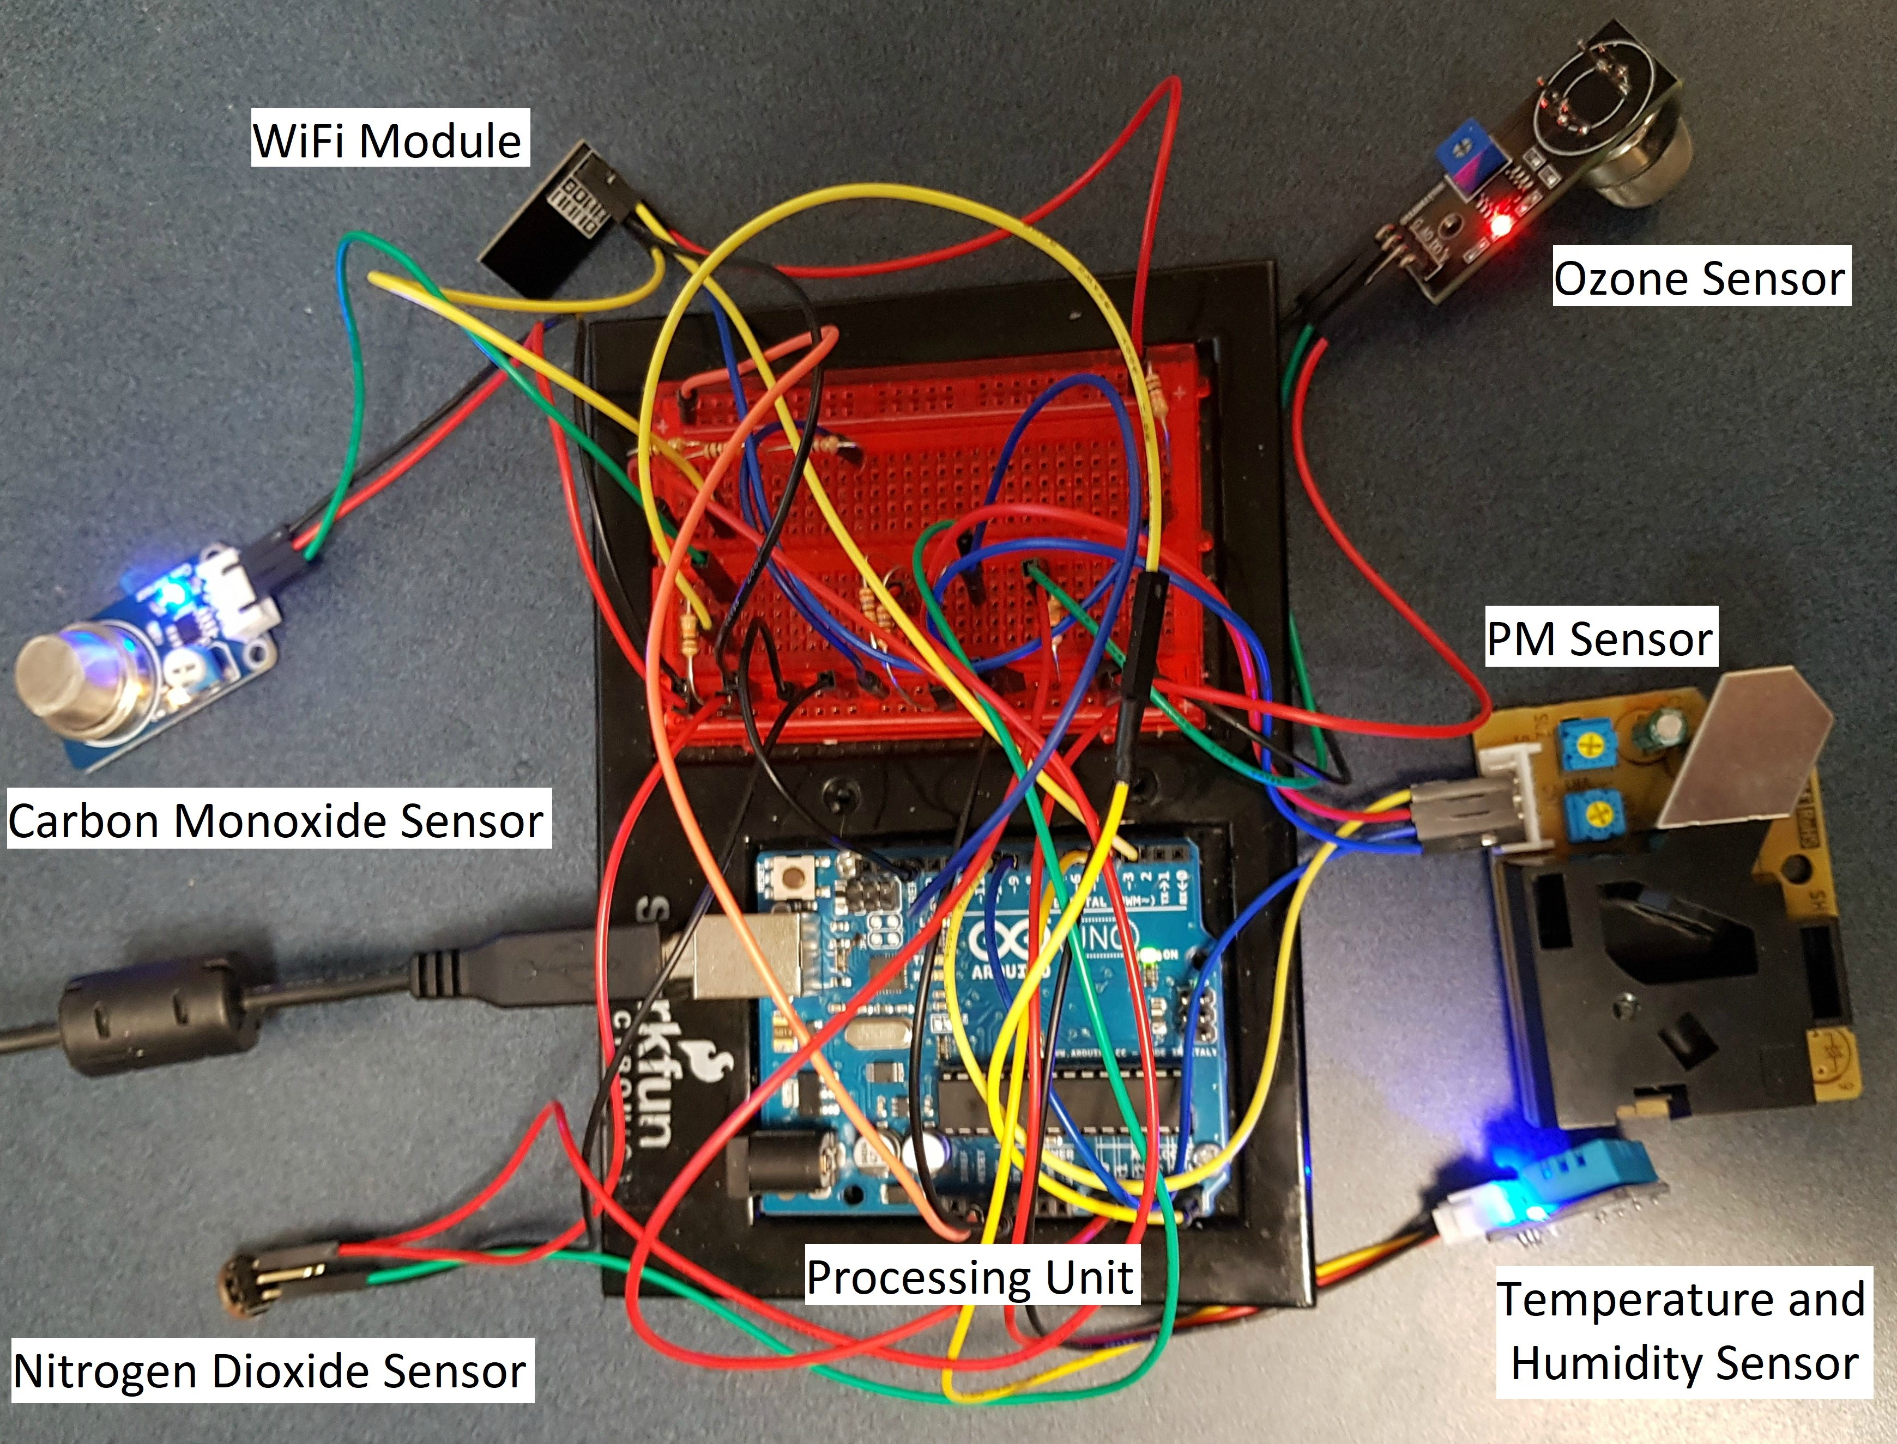

## Fig. 2: A Prototype Implementation

The system shown in Fig. 2 has three main hardware components: (i) Sensors; (ii) Microcontroller board; and (iii) WiFi communication module. It is setup to communicate with an open source IoT software platform called Thinkspeak [16]. These components are briefly described next.

1. *Sensors:* In addition to temperature and humidity sensors, we integrated four sensors into our system to measure four major pollutants such as *PM,O*3*,NO*2, and *CO*. Additional sensors can be easily integrated into our setup. The PM sensor Shinyei PPD42 that we integrated in our system can measure both *PM*2*.*5 and *PM*10. The MQ series sensors MQ-131 and MQ-2, respectively, are used to measure the concentration of *O*3 and *CO* in the air. The MICS-2714 sensor is used to measure the concentration of *NO*2 in the air.
2. *Microcontroller Board:* For simplicity and ease of programming, we use Arduino Uno which internally has ATmega328 microcontroller board. Since it is open-source based platform with rich software support, it is a widely used platform for various applications. Arduino supports both digital and analog inputs. It has 14 digital pins and 6 analog pins, and has shield to connect with both Ethernet and WiFi. As edge computing is preferred in this context, most of the calculation such as measuring gas concentration and computing air quality and air quality health indices are done in Arduino.
3. *Communication Link:* For the sensor device to communicate with the IoT software platform for data analytic and visualization services, we use ESP8266 WiFi module that has a networkable microcontroller. This module is very compact and has high durability and power saving features. Once the module is connected to the network it can transfer the data from Arduino to the specified IoT platform by using simple write commands.
4. *IoT Software Platform:* We use an open source IoT platform called Thingspeak [16]. It is integrated with the system to aggregate, analyze, visualize, and store the sensor data that we collect [16]. Thinkspeak can allow many users to integrate their system with other systems for collective and cooperative analysis of sensor data and promote citizen science in solving important global problems. It also offer a ‘hub’ model for data repository and a set of APIs for accessing and using the sensor data for their analysis and interpretations. Thinkspeak provides an intuitive user interface that is easy to understand. It also provides a mobile application called Thingview which can be installed on our phone and the same data from the system can be visualized simultaneously.

For our purpose, we use Thinkspeak to display the results. As soon as the value is transferred to Thingspeak, it can immediately draw graph showing online visualization. We have used eight channels of Thingspeak for the graph representation of all the pollutants measured by the sensors and the AQI and AQHI metrics. Next demonstrate the operation of our prototype by displaying sensor values and AQI and AQHI metrics.

# IV. EXPERIMENTATION

As the system design and implementation is just completed, the experiment we conducted is very limited. The purpose of this experiment is to show the system is operational. For deeper analysis of the data, we are planning to collect data for a longer period of time. In addition to temperature and humidity, we can measure *PM*2*.*5*,PM*10*,O*3*,NO*2, and *CO*.

Based on these values, we can compute both AQI and AQHI.

Typically AQI and AQHI are displayed in line graphs. We feel this graphic representation is not intuitive enough for the public. Therefore, we have created a color coded display with a needle showing AQI and AQHI values at any moment. AQI values range from 0 to 500. For simplicity and comparison with AQHI, we scaled it down to 1 to 10. Due to space limitation, here we show only graphs for *PM*2*.*5*,NO*2, AQI, and AQHI.

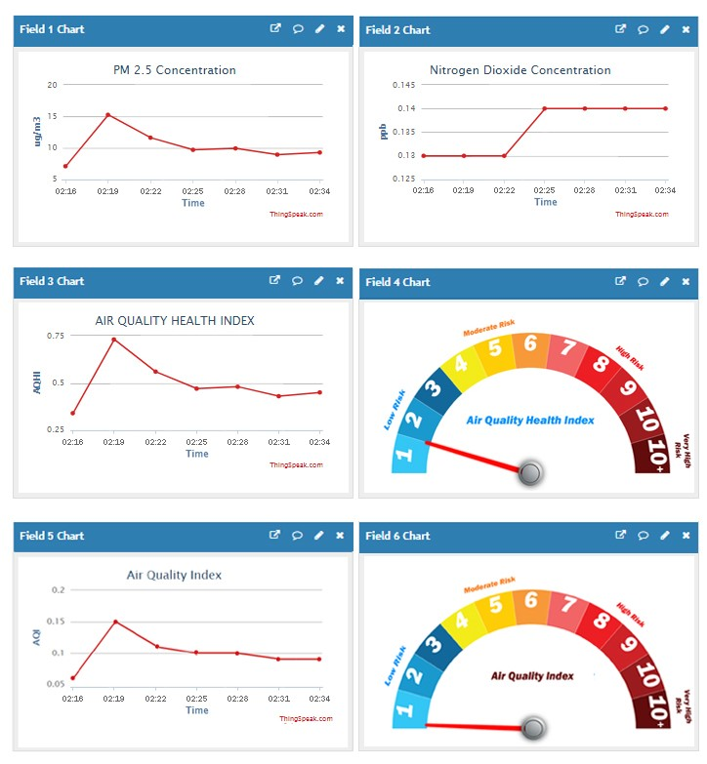

## Fig. 3: Output Displays

Although the trends of AQI and AQHI are similar, AQHI is pronounced higher than AQI. Notice that there is a slight difference between the value in left side AQI graph (i.e., .75) and the value pointed by the needle in the right side display (i.e., 1). The left side graph displays the values without applying ceiling and right side displays the value with ceiling applied as suggested in the original AQI calculation formula.

### A. Related Works

Air pollution monitoring is a hot research topic due to the increasing concern on the adverse effects of air pollution to health [17]. A survey of sensor based air pollution monitoring system is presented in [18]. Although many studies have focused on this topic, only a few discuss the outdoor air quality. Most of the studies focused on indoor air quality due to its relative simplicity [5], [6]. As far as the outdoor air quality is concerned, the number of the pollutants and their range vary from location to location. Using commodity hardware to design particulate matter was proposed in [9]. A few papers have focused on designing software for IoT and air pollution systems [2], [7], [13]. Using public transport and crowd sourcing to collect sensor data are suggested in [4], [17]. Another study proposed a personal air pollution monitoring system device that can measure *PM*2*.*5 and operate on batteries [15]. The importance of cyber-physical system to solve global issues have been discussed in [2], [14].

Although the above discussed systems are aimed at designing air pollution monitoring system, they are proposed for specific conditions and they lack generality and simplicity. Another limitation of the above cited works are that they do not discuss the calibration of sensors or neglect the importance of calibration of a sensor. Our research shows that calibration is key when it comes to the gas sensors. We have calibrated our sensors and the calibration algorithm will be included in our full report.

# V. CONCLUDING REMARKS

In this paper, we proposed a novel framework for pervasive air pollution monitoring system. The feasibility and the efficacy of the framework is demonstrated by building an air pollution monitoring system in our lab. We have shown the sample results using simple graphs. This is an ongoing work and part of the first author’s thesis work. This is our first functional prototype and we will be working on refining its design and packaging it with 3D printed case to deploy outdoor and collect data for analysis.

# REFERENCES

1. G. Anthes, Open source software no longer optional, *Communications of the ACM*, 59(8):15-17, 2016.
2. A. Bagnato, et. al., Designing swarms of cyber-physical systems: the H2020 CPSwarm Project, *ACM International Conference on Computing Frontiers*, Invited Paper, 305–312, 2017.
3. H. Chen and R. Copes, Review of air quality index and air quality health index, *Environmental and Occupational Health Report*, 2013.
4. Joy Dutta, et. al., . Towards smart city: sensing air quality in city based on opportunistic crowd-sensing. *Proceedings of the 18th International Conference on Distributed Computing and Networking*, 42:1–6, 2017.
5. B. Fang, et. al., AirSense: an intelligent home-based sensing system for indoor air quality analytics. *Proceedings of the 2016 ACM International Joint Conference on Pervasive and Ubiquitous Computing*, 109–119, 2016.
6. M.F.M Firdhous, et al., IoT enabled proactive indoor air quality monitoring system for sustainable health management. *Proceedings of the 2nd International Conference on Computing and Communications Technologies (ICCCT)*, 216–221, 2017.
7. G. Guan, et. al., TinyLink: a holistic system for rapid development of IoT applications, *The 23rd ACM Annual International Conference on Mobile Computing and Networking (MobiCom)*, 2017.
8. E. Hand, People power, *Nature*, 466:685-687, 2010.
9. Holstius, Monitoring particulate matter with commodity hardware, *PhD Thesis*, University of California Berkeley, 2014.
10. State of global air, *A Special Report on Global Exposure to Air Pollution and its Disease Burden*, Health Effects Institute, 2017.
11. I. Hadzic, Y. Abe, H. C. Woithe, Edge computing in the ePC a reality check, *Proc. of the Second ACM/IEEE Symposium on Edge Computing*, 13:1-10, 2017.
12. Rise of the citizen scientist, *Nature (Editorial)*, August 2015.
13. M. Rahman, et. al., Adaptive sensing using IoT with constrained communications, *ACM/IFIP/USENIX Middleware Conference*, 6 pages, 2017.
14. John A. Stankovic, Research directions for cyber-physical systems in wireless and mobile healthcare, *ACM Transactions on Cyber Physical Systems*, 1(1):1:1–12, 2016.
15. M. S. Wong, et al., Development of a personal integrated environmental monitoring system. *Sensors*, 14(11):22065–22081, 2014.
16. https://thingspeak.com/
17. J. Q. Yu, et. al., Sensor deployment for air pollution monitoring using public transportation system. 2012 *IEEE Congress on Evolutionary Computation*, 2:1–7, 2012.
18. W. Y. Yi, et. al. A survey of wireless sensor network based air pollution monitoring systems, *Sensors*, 15:31392-31427, 2015.

1. AQHI is the first tool to characterize the cumulative nature of poor air quality on health and recognized internationally.